Bald Eagles: A Conservation Success Story
A March 2, 2022 Talk

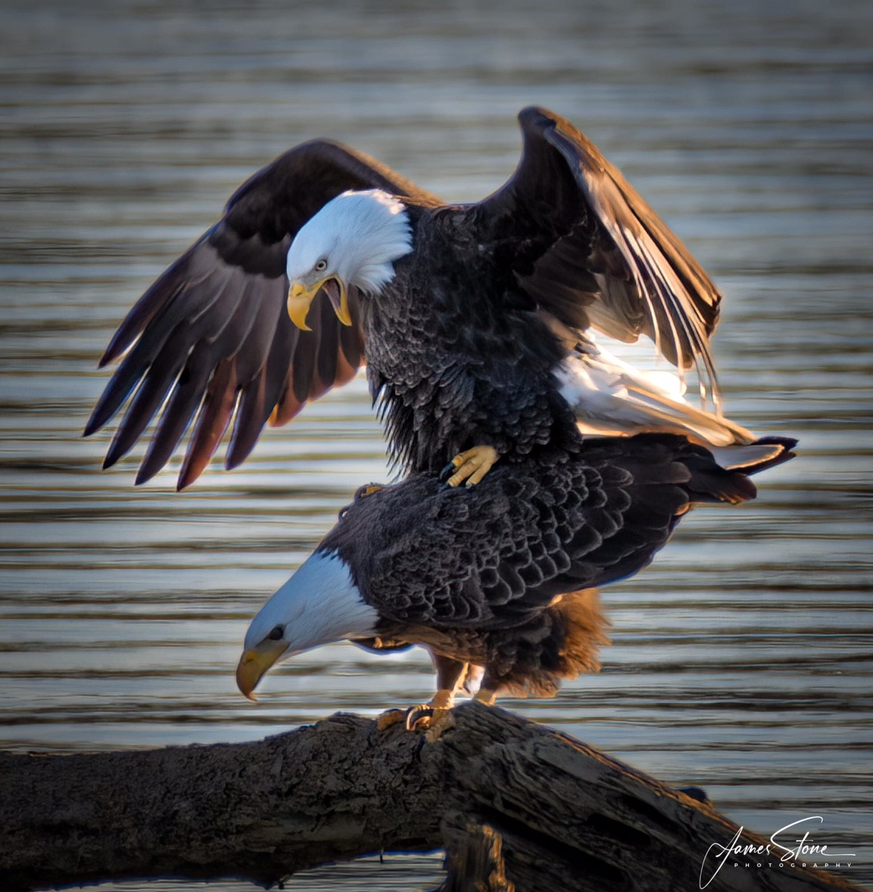
Photo by James Stone

Bald and golden eagles will be the focus of a presentation on March 2, 2022, by Jeff Cooper, a Virginia Department of Wildlife Resources (DWR) wildlife biologist. Cooper will explore eagle biology, recent research, the bald eagle’s recovery and the importance of the Chesapeake Bay region to bald eagles. This Zoom meeting will start at 7 p.m.

Register in advance at: https://us06web.zoom.us/meeting/register/tZUudeyprD0tGd3X0qQP1pJ3j6XxqziP2btn or scan the above QR code on your phone. You will receive a confirmation email.
The sponsors of this program are the Friends of Dyke Marsh, the Friends of Huntley Meadows Park, the Friends of Mason Neck Park, the Northern Virginia Bird Club and the Audubon Society of Northern Virginia.
